Literary Text Analysis Quick Reference

Objective Summary: https://www.youtube.com/watch?v=dkzHa7PHQqI
1) Open first with ONE sentence that identifies the title, author, and main idea or central theme of the story- think
exposition. Who is the story about? What happens? Where does it happen? Why does it happen- what’s the conflict?
2) Do NOT include opinions, or “I think”, ANYWHERE, but DO write in your own words.
3) After the topic sentence, create a timeline of key events in paragraph form- be SURE it’s in chronological order
*First, Cinderella is forced to do all the chores at home.
Next,
Then,
Finally,
4) Do NOT include unnecessary details, or quotes- keep it SHORT (it’s a summary after all).

Student example of an objective summary
“11:59” by Patricia McKissack tells the story of Lester Simmons, a retired Pullman car porter, trying to escape death.
First, Lester tells stories about the Union and how it was the first black Union. He tells the porters how to do their jobs and continues with his many stories. As the stories continue, Lester begins the story of the 11:59.
Then, Lester explains that the 11:59 is a whistle that blows and twenty-four hours later you die. He continues to tell the porters how a person cannot escape the Death Train.
Conveniently, as he just finishes the story, he feels a pain in his chest, and he hears the whistle. Lester tries everything to prevent himself from dying.
In the end, Lester ignores the obvious signs of a heart attack and has a vision of his friend. His friend lets him know it is time to go and Lester passes away at exactly 11:59.

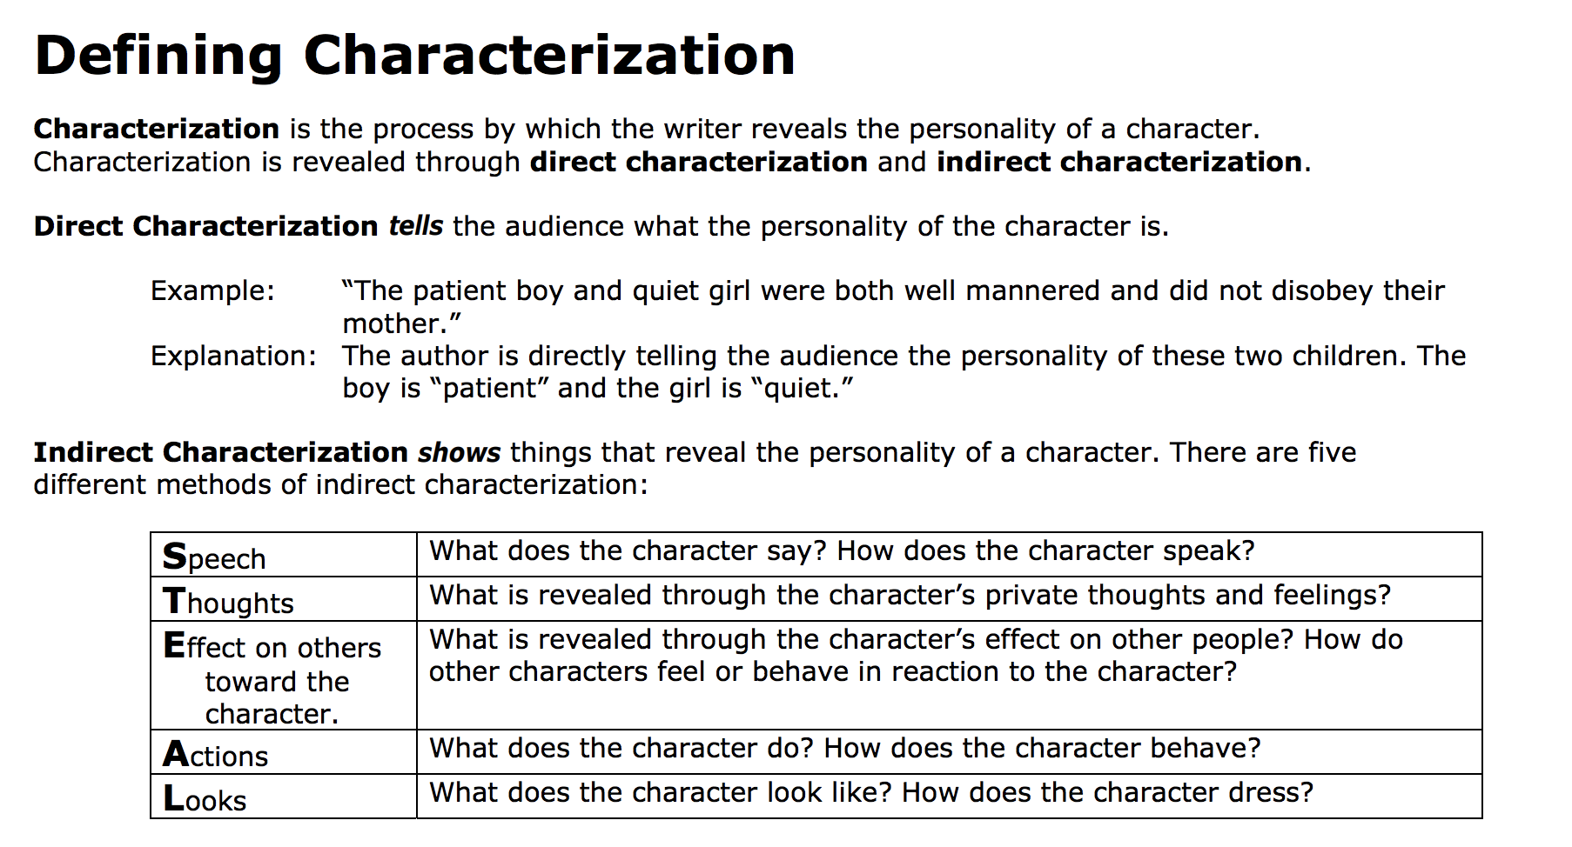
Direct Characterization: Gary is a nice and caring person.
Indirect Characterization: Gary watched his little brother for two hours while their mother was ill, taking care of his every need. He did this without being asked, and he did not ask for anything in return.

Theme is not specific to any one story. It is a moral or message that the author is trying to send to the reader; it is a universal idea. A theme is written in a complete sentence, but it is not a cliché. It is usually not explicitly stated in the text, but must be inferred.

Theme examples
Newcomers in strange environments can face great risks.
Friends can be the key to survival.

